Installation Instructions

Download Section:

* For installation, the general sense is one of two options:
  + The simplest is for programmers using the GIT terminal interface, paste: [git@github.com](mailto:git@github.com):uriar003/POS-system.git into a folder directory.
    - 
  + Otherwise, make your way too <https://github.com/uriar003/POS-system> and download a zip folder and place it somewhere safe in your computer. We would recommend in your program folder, or your Documents folder for easy access.
    - 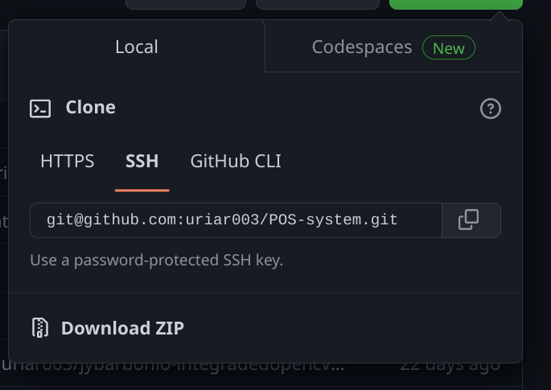

Project Setup Section:

* For this portion, we need to begin downloading Python so that we can easily compile the code.
  + Windows/Apple:Begin by going to <https://www.python.org/downloads/> and download the programming language by following their instructions. It will have you follow the prompts and you’ll be ready in not time!
  + Linux: It’s very simple, open your command line terminal and type: sudo apt-get install python3
  + 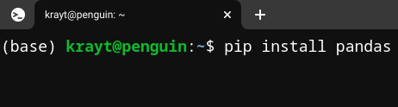
* Once you’ve done this we’ll be moving into the terminal, we need to begin installing a few python packages by using the pip interface, please copy each of these one by one:
  + pip install kivy
  + pip install kivymd
  + pip install pandas
  + pip install openpyxl
  + pip install numpy
  + pip install cv2
  + pip install pyzbar
    - If you’re using linux you may need to also past: sudo apt-get install zbar-tools
  + pip install pyinstaller
  + pip install docx
  + pip install bcrypt
* Once done, we’re almost complete.
* We need to open a terminal inside the gui folder, (type cd in windows or pwd on Linux/Mac and you should see this)
  + 
* Once Paste: pyinstaller gui.spec
  + This can take around 10 minutes to compile.
* Once complete, a dist folder will appear and inside will be a file called POS_Application. Save a shortcut to your taskbar, or wherever you’d like and you’re ready to start using the POS!